##################

# Scatter Plot -#

##################

# Clear the workspace

**rm(list = ls())**

# NOTE:

# Uncomment the code lines wherever required (Ex: Package installation..)

# set the working directory: Recommended

# It will enable in keeping all the plots in one location.

# use setwd() & getwd() functions

# Install & load the package " ggplot2 "

**# install.packages("ggplot2")**

**library(ggplot2)**

# Understand the skeleton of ggplot() function

# ggplot( data = df/matrix, mapping = aes( asthetic arguments) )+

# geometric_object() + Optional_Function()

# plotting a scatter diagram using iris3 package

**View(iris)**

**ggplot(data=iris,mapping = aes(x=Sepal.Length, y=Petal.Length ))+**

**geom_point()**

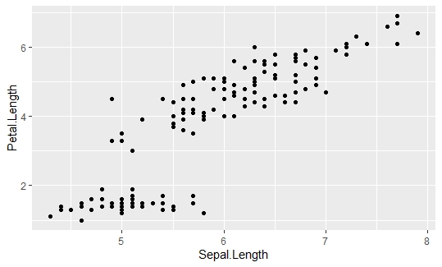

# Saving the plot: using ggsave() function

# Alternate method: Goto Plots-> Export -> Save in required format

**ggsave("Scatter_SLPL.jpg")**

# color the scatter points according to species:

# Two options for placing color parameter in ggplot(aes)/geom_point()

**ggplot(data=iris,**

**mapping = aes(x=Sepal.Length, y=Petal.Length,**

**color=Species))+**

**geom_point()**

**ggplot(data=iris,**

**mapping = aes(x=Sepal.Length, y=Petal.Length,))+**

**geom_point(aes(color=Species))**

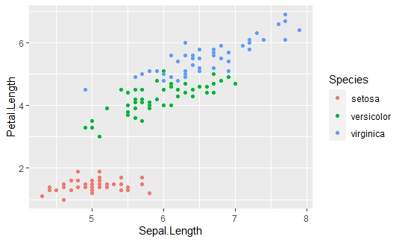

# Fit a linear regression line

# You can save the plot codes in data object too

# It is good practice & can reuse the code just by using object

**myplot <- ggplot(data=iris,**

**mapping = aes(x=Sepal.Length, y=Petal.Length,))+**

**geom_point(aes(color=Species))**

**myplot + stat_smooth(method = "lm", se = TRUE, size = 1)**

# In the above code change the parameter values & observe the changes:

# se =true/false size=1/3/5

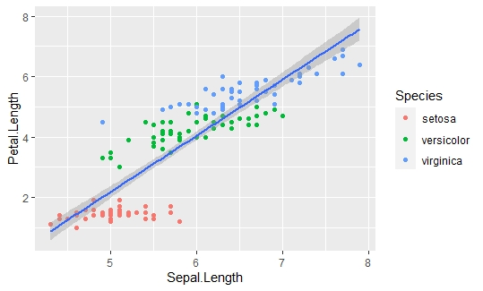

# Adding Information to the graph ( labels )

**myplot1 <- myplot + stat_smooth(method = "lm", se = TRUE, size = 1)**

**myplot1 + labs(title = "TITLE LINE", subtitle = "Sub-title Line",**

**caption = "Caption Field", x="X-axis Name", y="Y-axis Name")**

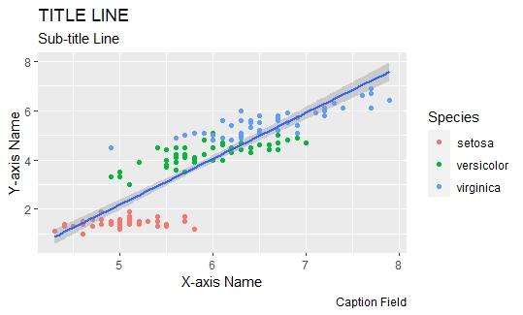

# Adding the theme:

**myplot2 <- myplot1 + labs(title = "TITLE LINE", subtitle = "Sub-title Line",**

**caption = "Caption Field", x="X-axis Name", y="Y-axis Name")**

**myplot2 + theme_bw()**

**myplot2 + theme_dark()**

